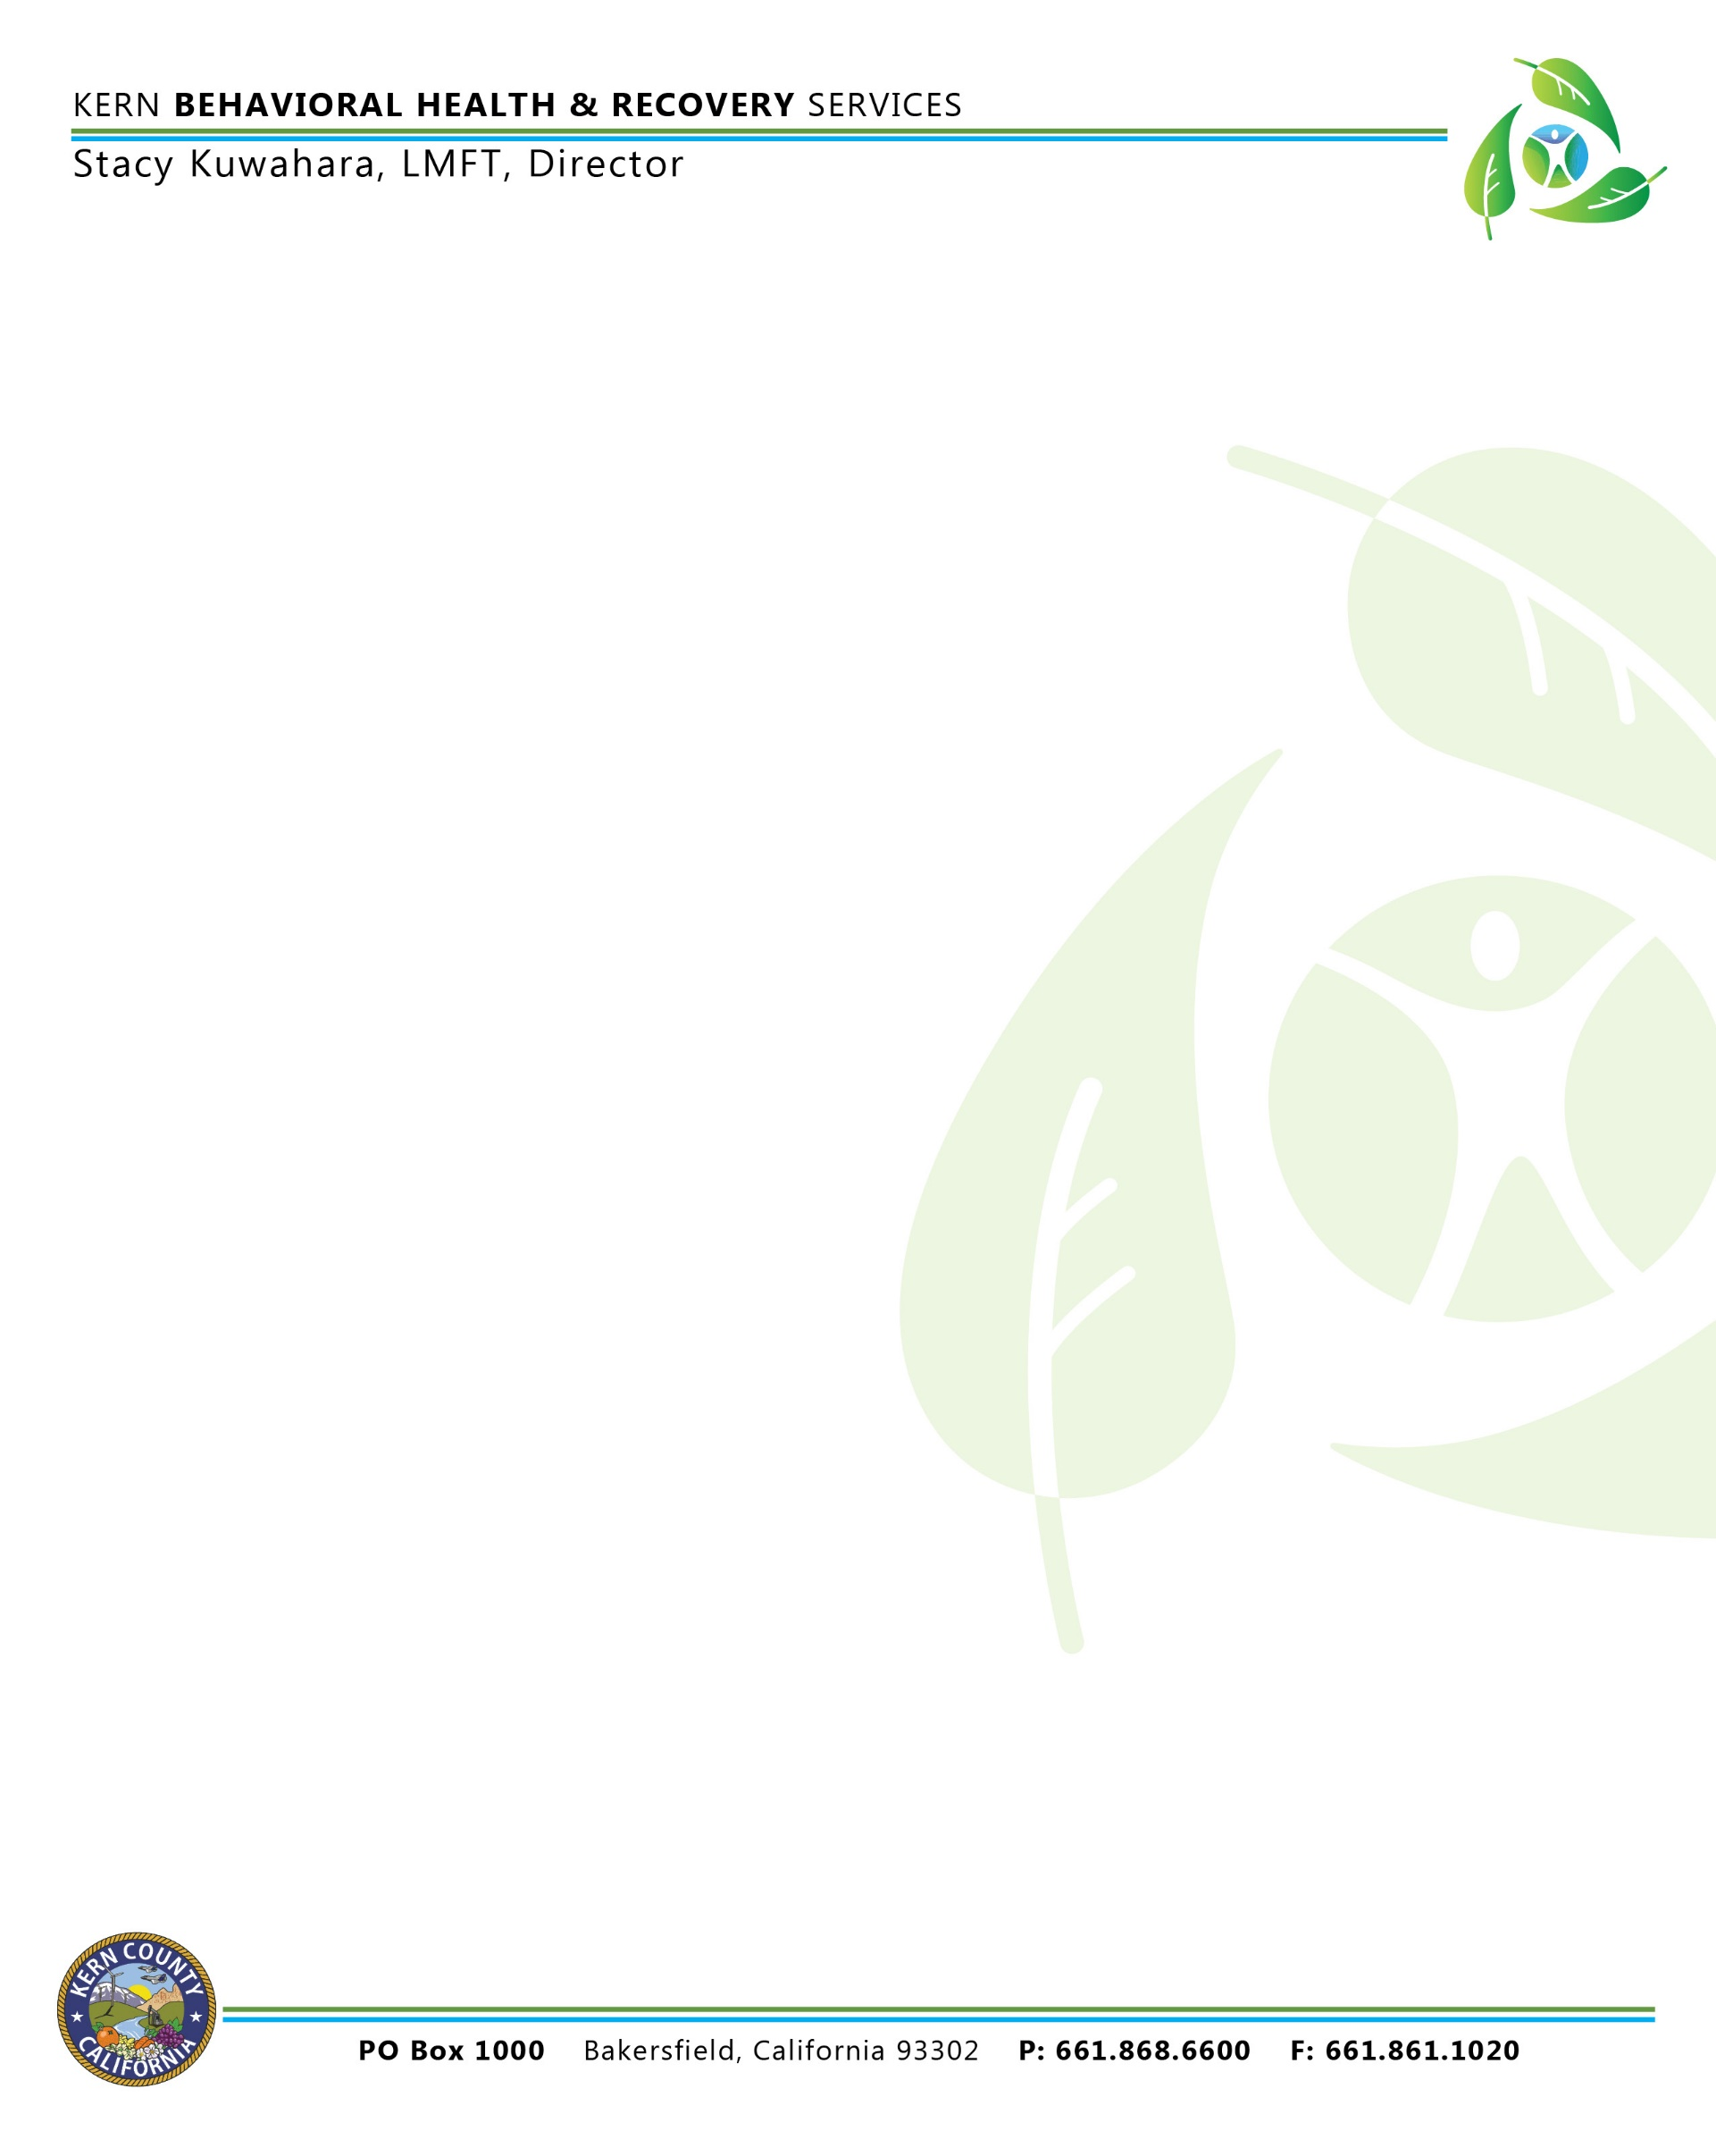

YOUR HEARING RIGHTS

You have only 90 days to ask for a hearing. The 90 days start either:
- The day after we personally gave you this the mental health plan’s appeal decision notice, OR
- The day after the postmark date of this mental health plan’s appeal decision notice.
- You must exhaust the mental health plan’s problem resolution process prior to filing for a State Fair Hearing.

Expedited State Hearings

It may take approximately 90 days from the date of your request to receive a hearing decision. If you believe this timing will cause serious problems with your mental health, including problems with your ability to gain, maintain or regain important life functions, you may request an expedited state hearing.

To request an expedited hearing, please check the 1st check box in the How to Ask
For a State Hearing section under HEARING REQUEST and include the reason why you are requesting an expedited hearing.
If your expedited hearing request is approved, a hearing decision will be issued within three working days of the date your request is received by the State Hearings Division.

To Keep Your Same Services While You Wait for A Hearing

- You must ask for a hearing within 10 days from the date the mental health plan’s appeal decision notice was mailed or personally given to you or before the effective date of the change in services, whichever is later.

- Your Medi-Cal mental health services will stay the same until a final hearing decision is made which is adverse to you, you withdraw your request for a hearing, or the time period or service limits for your current services expire, whichever happens first.

State Regulations Available

State regulations, including those covering state hearings, are available at your local county welfare office.

To Get Help

You may get free legal help at your local legal aid office or other groups. You can ask about your hearing rights or free legal aid from the Public Inquiry and Response Unit:

Call toll free: 1-800-952-5253
If you are deaf and use TDD, call: 1-800-952-8349

Authorized Representative

You can represent yourself at the state hearing. You can also be represented by a friend, an attorney or anyone else you choose. You must arrange for this representative yourself.

Information Practices Act Notice (California Civil Code Section 1798, et. seq.)

The information you are asked to write in on this form is needed to process your hearing request. Processing may be delayed if the information is not complete. A case file will be set up by the State Hearings Division of the Department of Social Services. You have the right to examine the materials that make up the record for decision and may locate this record by contacting the Public Inquiry and Response Unit (phone number shown above). Any information you provide may be shared with the mental health plan, the State Departments of Health Services and Mental Health and with the U.S. Department of Health and Human Services (Authority: Welfare and Institutions Code, Section 14100.2)

HOW TO ASK FOR A STATE HEARING

The best way to ask for a hearing is to fill out the section below. Make a copy of the front and back for your records. Then send this page to:

State Hearings Division
California Department of Social Services
P.O. Box 944243, Mail Station 19-37 Sacramento, CA 94244-2430

Another way to ask for a hearing is to call 1-800-952-5253. If you are deaf and use TDD, call 1-800- 952-8349.

HEARING REQUEST

I want a hearing because of a Medi-Cal related action by the Mental Health Plan of Kern County.
Check here if you want an expedited state hearing and include the reason below. Reason:

My name: (print) My Social Security Number: My Address: (print)_ My Phone Number: My signature: Date:

I need an interpreter at no cost to me. My language or dialect is:

I want the person named below to represent me at this hearing. I give my permission for this person to see my records and to come to the hearing for me.
Name: Address: Phone number:

